- Visit: www.nassauflpa.com and click on “Property Search”

- Type your address into “Property Address” field and click “Go”. Once you’ve hit “Go”, the property information will display underneath. Click on the Parcel Number.
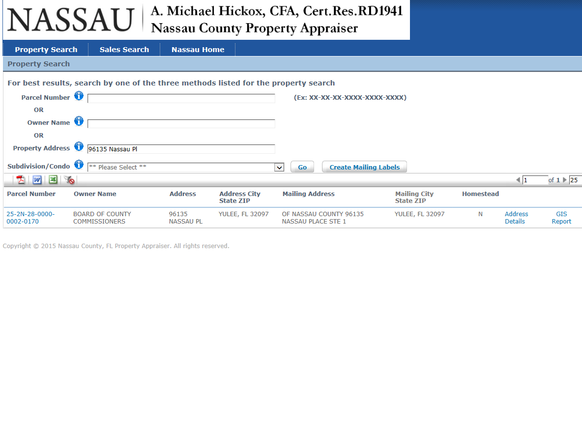
Parcel Number

- When this screen appears, click on “Map This Parcel” on the top right of screen
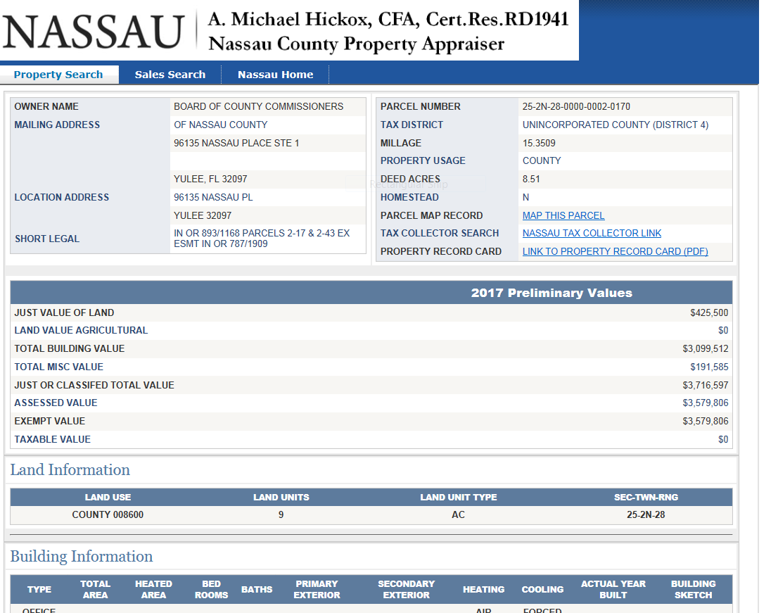

- An aerial map will be generated. Once the map loads, close any disclaimer boxes that appear so you can see just the aerial view. From there, click on “Map Layers”
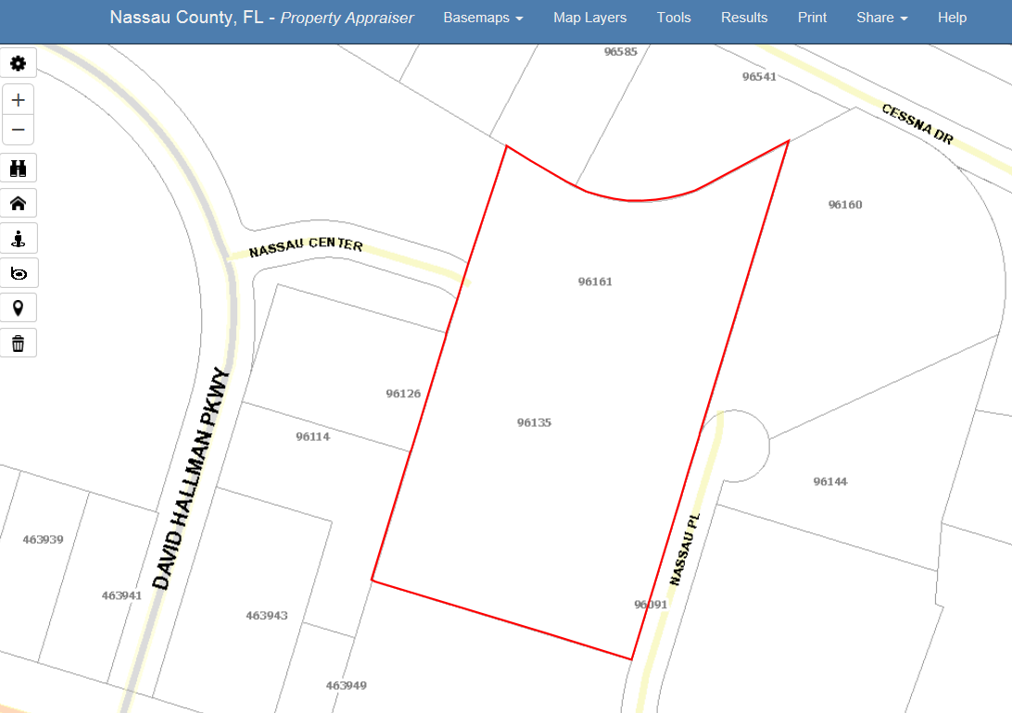

- This map layer box will appear. Click on “Public Safety” to activate evacuation zones
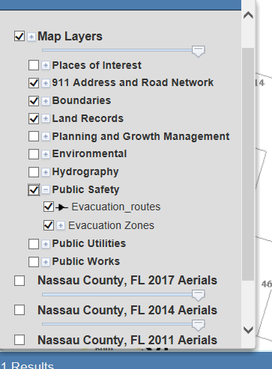

- Below is an example of what the Evacuation Zone will reflect for your property. The property is this example is in Evacuation Zone D.

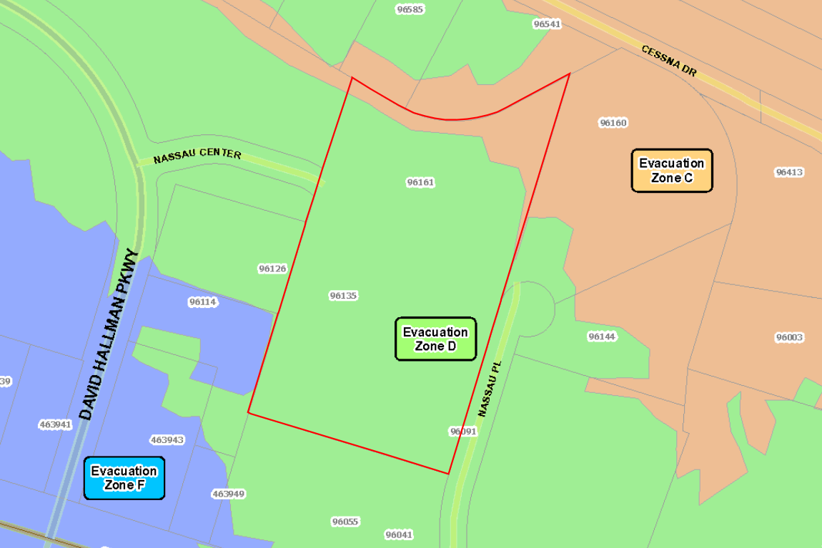

Note: Evacuation Zones are simply to tell you which zone you are located in so you can be aware when evacuations are announced. They will be announced by Zone beginning with Zone A.

